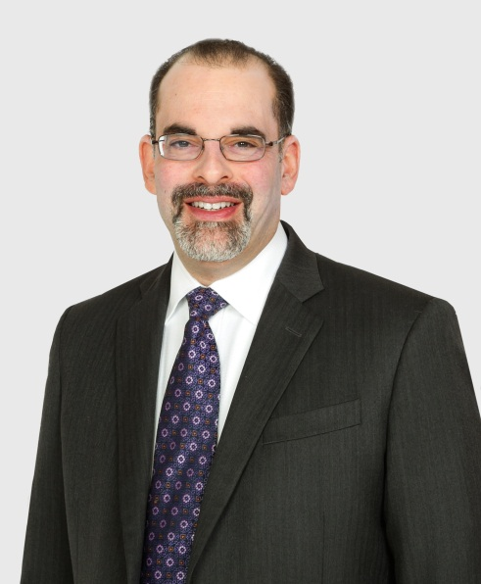

|  |  |
| --- | --- |
|  | **Steven A. Kronenberg**  Attorney  20 Haight Street 888-504-0157 phone  San Francisco, CA 94102 415-771-5845 fax |

**Bio**

|  |  |
| --- | --- |
| Steven A. Kronenberg is an attorney on the Label Trial Team. Mr. Kronenberg's practice helps the catastrophically injured and focuses on:   * Catastrophic Injury: including representing people who consumed food allergens or pathogens, as well as workers who used defectively designed or manufactured food processing equipment, victims of traumatic brain injury, spinal cord trauma, nerve damage, and severe orthopedic injuries arising from construction accidents, industrial accidents, dangerous premises, auto accidents, wrongful death, governmental or public entity liability, and professional negligence. Mr. Kronenberg has more than a decade of experience litigating personal injury and product liability cases from their inception through trial and appeal. * Consumer Protection: litigating class action claims arising from food fraud, false advertising, and product defects. Mr. Kronenberg works to hold these companies accountable for violating federal and state laws. * Employee Rights: helping workers who have suffered discrimination, retaliation, wrongful termination, or wage and hour violations.   Mr. Kronenberg lives in San Ramon, where he enjoys spending time with his family. | **EDUCATION**   * Temple University School of Law, Philadelphia, Pennsylvania * Juris Doctor – 2001 * Honors: Dean’s List, 1999, 2000, 2001 * Honors: Distinguished Class Performance: Trial Advocacy II, Administrative Law * Law Review: Political & Civil Rights Law Review, Staff Member, 1999 * Law Review: Political & Civil Rights Law Review, Symposium Editor, 2000 - 2001   **BAR ADMISSIONS**  • California  **AREAS OF PRACTICE**  • Construction Accidents  • Workplace Injuries  • Personal Injury Accidents  • Dangerous Property  • Defective Products |

Publications

* Tip of the iceberg: tip skimming is an underreported problem, Plaintiff Magazine, June, 2016
* Food Safety: Records Help Identify Target Defendants and Trigger Insurance Coverage, Plaintiff Magazine, August, 2015
* Food Processing – A Dangerous Place to Work The machinery used to process food products may present products liability opportunities in addition to the WC remedy, August 01, 2014
* Food Law – “Natural” Food and Artificial Injustice, August 01, 2013
* Food Allergy Risk Management: More Customers, Less Liability, Journal of Foodservice Business Research, March 7, 2012

Speaking Engagements

* Panelist, Food Safety: Top Risks and How Do You Protect Your Restaurant?, Golden Gate Restaurant Association Industry Conference, April 12, 2016
* There’s WHAT In My Corn Flakes?! A Food Law Update, Consumer Attorneys of California (CAOC), December 2, 2015
* Speaker, Food Law Update, SFTLA Tahoe Ski and CLE Seminar, January 2015
* Interviewed in U.S News & World Report, “Supplier: No listeria in product before going to Blue Bell,” September 22, 2016
* Interviewed in Larry Olmsted’s New York Times Bestseller, Real Food Fake Food, published July 2016
* Interviewed in Bloomberg Businessweek, “Rotten Tomatoes: Farmers Pay the Price for a False Food-Safety Warning,” September 29, 2014

Honors and Awards

* Selected to the Northern California Super Lawyers List – Top 5% of attorneys, as voted by peers
* AV Preeminent - Martindale Hubbell
* Avvo: 10

Professional Associations and Memberships

* Alameda-Contra Costa Trial Lawyers Association, Member
* American Association for Justice, Member
* Consumer Attorneys of California (CAOC), Board of Governors at Large for the Northern District
* San Francisco Trial Lawyers Association, Member
* California Employment Lawyers Association (CELA) Legislative Committee, Member